

EMPLOYEE LEAVE AND PAYROLL MANAGAMENT SYSTEM – Deliverable 2

Course: Software Engineering
Instructor: Ms. Rabail Zahid

Submission Date: 25th March 2025

BY:
The Scytes
Ruhab Ahmad (23I-0559)
Hasan Altaf (23I-0698)
Muhammad Saqib (23I-0769)

INTRODUCTION
The Employee Leave and Payroll Management System is a Java-based business management application designed to automate employee record handling, leave management, and payroll processing. The system improves organizational efficiency by reducing manual work and ensuring accurate record keeping.

PROJECT VISION
To develop a reliable business system that simplifies HR operations by providing automated employee management, leave processing, and payroll calculation.

INTENDED USERS
Stakeholders
- HR Manager
- Employees
- Organization Management
Stakeholder Needs
- Maintain employee records
- Manage leave requests
- Generate payroll
- Track attendance

FEATURES / FUNCTIONALITY
- Employee registration
- Leave request management
- Leave approval system
- Salary management
- Payroll calculation
- Record viewing
System helps by:
- Reducing paperwork
- Automating calculations
- Improving accuracy

USER STORIES
US-03 - View Employee Records (Leftover)
As an HR Admin I want to view employee list So that I can manage employee data
US-04 - Logout from System (Leftover)
As a System User I want to logout securely, So that unauthorized access is prevented
Employee Management
US-05 - Update Employee Record
As an HR Admin, I want to update employee information so that records remain accurate.
US-06 - Delete Employee Record
As an HR Admin, I want to remove employee records so that inactive employees are not stored.

NFR (NON-FUNCTIONAL REQUIREMENTS)
- System must respond within 2 seconds
- Data must be stored securely
- System must be user-friendly
- System must support multiple users
- System must be reliable

ITERATION 2 IMPLEMENTATION SCREENSHOTS
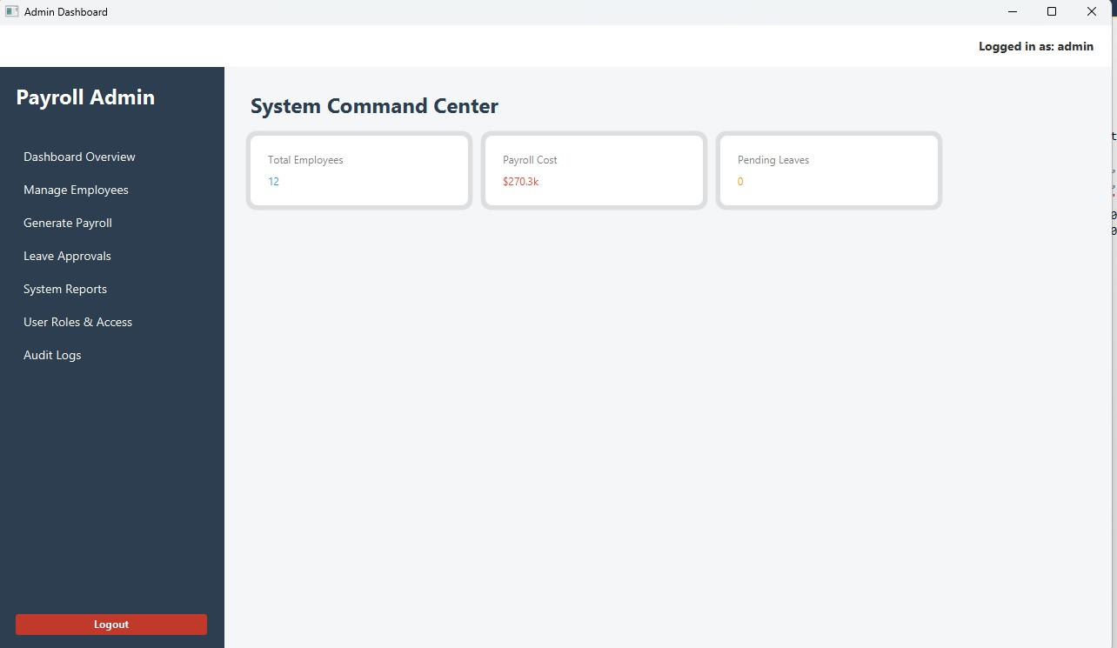
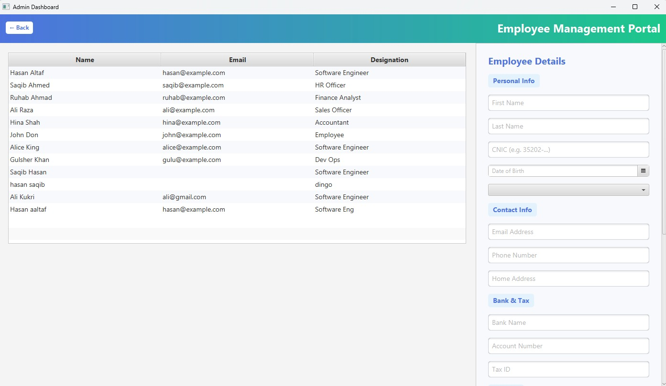
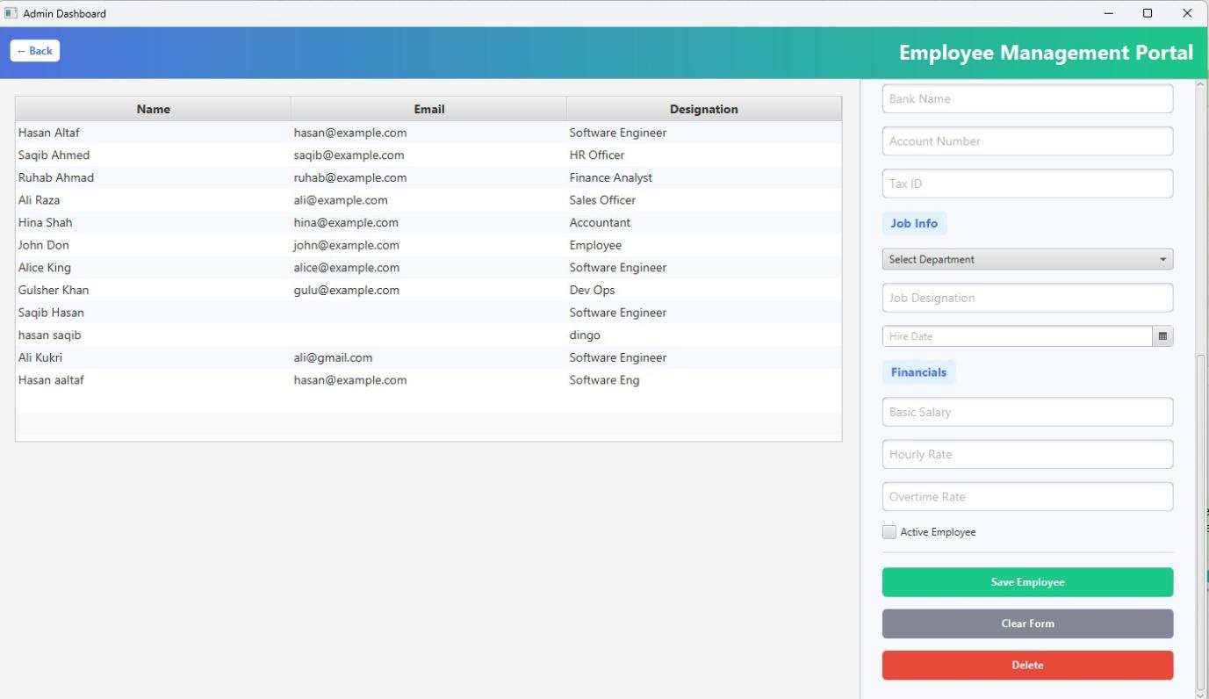
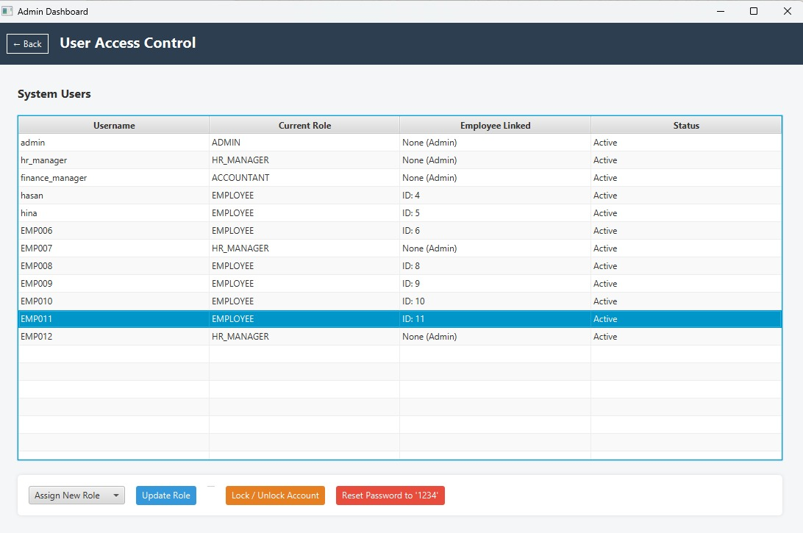


WORK DIVISION
Task | Responsible
Requirements | Ruhab
UI Design | Saqib
Implementation | All members
Scrum Management | Ruhab
Testing | All members

